MANGLOVE

# Objective:

The Smith & Nephew’s MANGLOVE developed using VBA customizations need to be converted to .NET framework in compatible with AutoCAD 2018, adhering to best practices, supporting 64 bit architectures.

# Overview:

MANGLOVE has 4 tabs “Left Glove”, “Left Spacers”, “Right Glove” and “Right Spacers” to draw Glove details and Web Spacer details in AutoCAD.

This document gives an outline of input details need to generate required output, working flow and output details of MANGLOVE module in Smith & Nephew project.

# Description:

# Scope:

* MANGLOVE module is used to draw Glove details (Left or Right Glove) and Web Spacer details (Left or Right Spacer) in the standard template drawing “SN.dwt” using the details from “MAINPATIENTDETAILS” block reference.
* For MANGLOVE module, first we need to update the attributes of “MAINPATIENTDETAILS” block reference using NEWPATIENT command. Without that, we can’t run MANGLOVE module.

# Technology:

We are using VB.net technology and AutoCAD 2018 for MANGLOVE.

# Deliverable:

AutoCAD 2018 customized plug-in DLL.

# Steps to Run:

1. Open AutoCAD 2018 and open a drawing using “SN.dwt” template file.
2. Run NETLOAD command in Command prompt.
3. Load the updated “SmithNephew.dll” file in AutoCAD.
4. Run NEWPATIENT command in Command Prompt and update the attribute values in “MAINPATIENTDETAILS” block reference.
5. Run MANGLOVE command in Command Prompt.
6. “Glove” dialog will be opened.
7. In that dialog, we have 4 tabs (Left Glove, Left Spacers, Right Glove and Right Spacers).
8. Enter the required details for required Part (Left Glove, Left Spacers, Right Glove and Right Spacers).
9. After entering details, click draw button.
10. Now, the required Glove details or Web Spacer details will be drawn successfully in AutoCAD.

# Dialog Design:

# Left Glove:

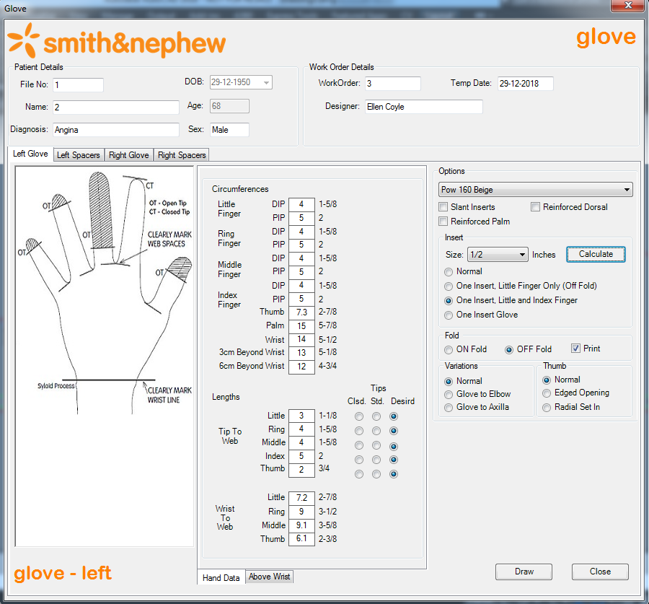

# Left Spacers:

To Draw Left Spacers, first we need to draw Left Glove. Because Left Spacers will read the values from Left Glove.

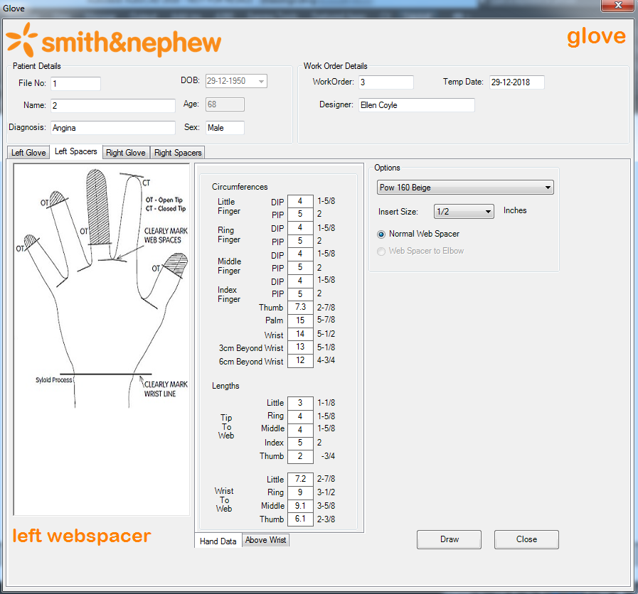

# Right Glove:

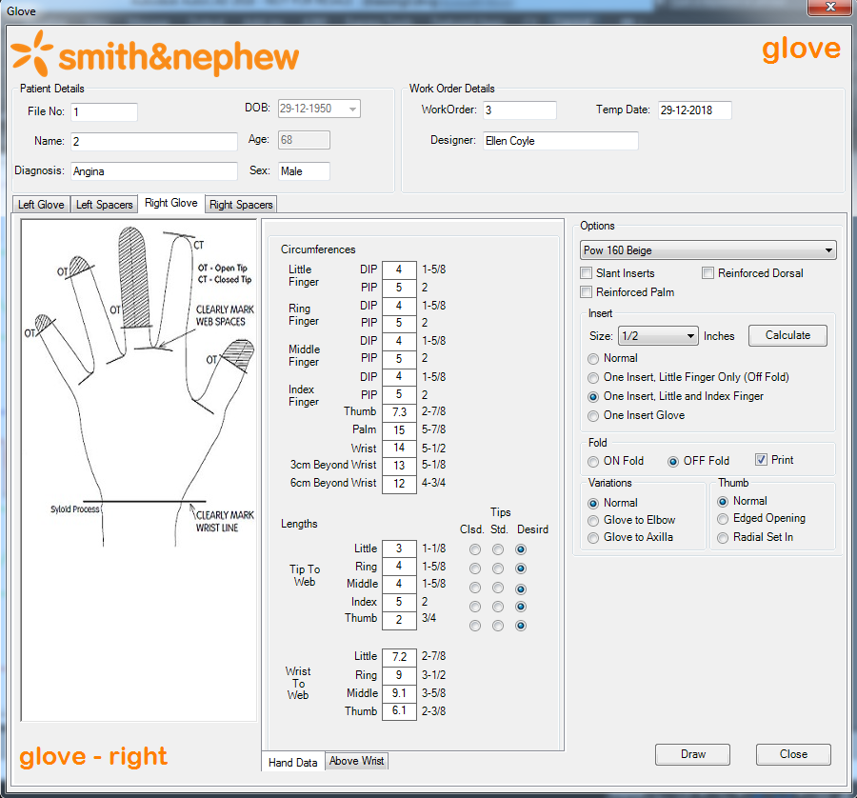

# Right Spacers:

To Draw Right Spacers, first we need to draw Right Glove. Because Right Spacers will read the values from Right Glove.

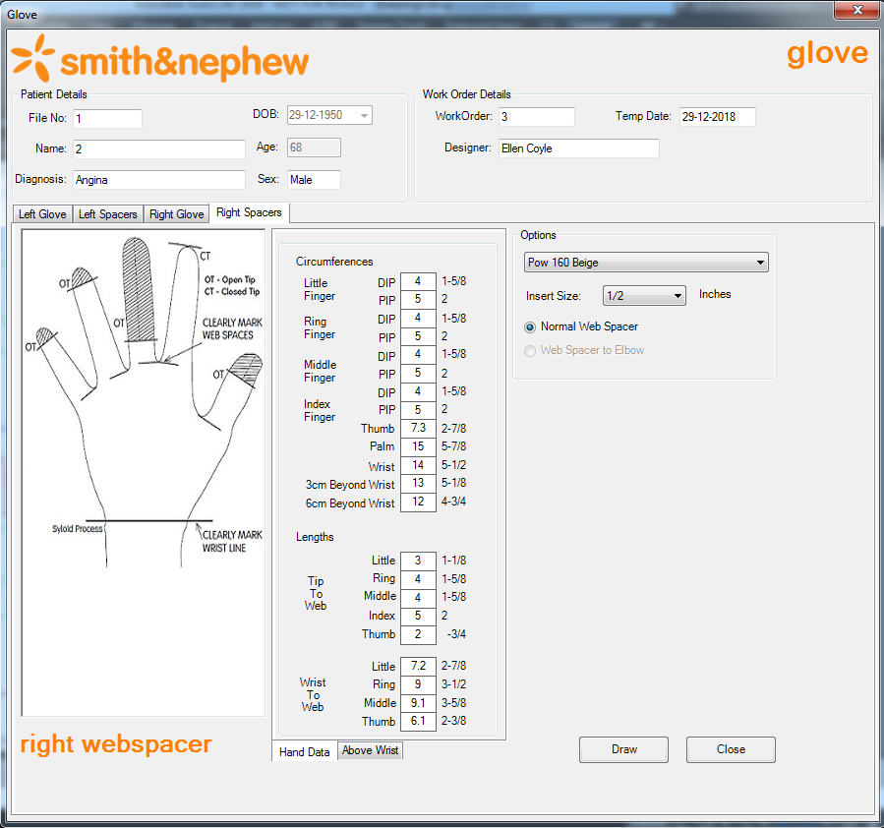

# Required Output:

# Left Glove:

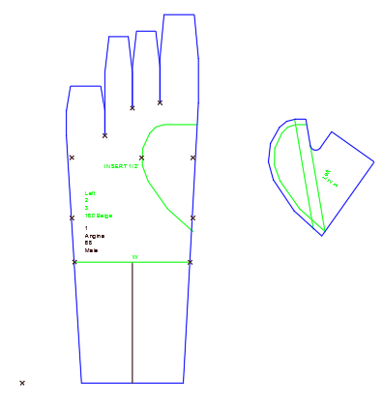

# Left Spacers:

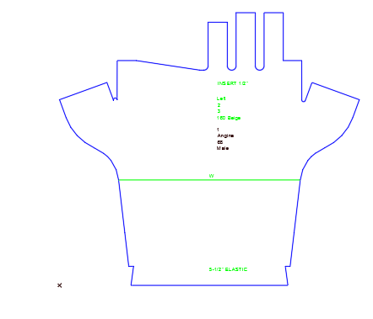

# Right Glove:

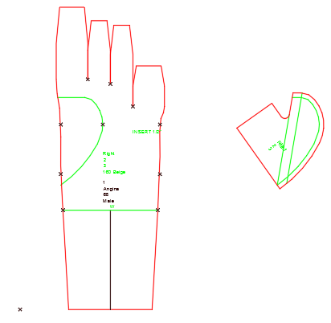

# Right Spacers:

